GitHub Repository: https://github.com/vesperhalcro-oss/Smart-Supply-Chain-Management-For-Rural-Area

Project Proposal: Rural Smart Supply Chain Management System

1. Project Objective
The objective of the Rural Smart Supply Chain Management System is to establish an offline-first, IoT-enabled, analytics-driven, and community-operated platform that connects rural agricultural producers directly with urban market hubs.
The platform reduces post-harvest losses, removes predatory intermediary costs, and maintains operational continuity in zero-connectivity environments through Progressive Web Application (PWA) interfaces, local data queues, Rust-ready edge telemetry, solar micro-hubs, hotspot analytics, and parcel-level tracking from farm gate to market.

2. Problem Statement / Need for the Solution
- First-Mile Transport Deficit: Conventional logistics providers bypass small-batch rural pickups due to unpaved roads, high fuel costs, and low margins.
- Severe Post-Harvest Losses: A lack of real-time environmental monitoring (temperature/humidity) combined with delayed transport leads to a 25%–40% spoilage rate for fresh produce.
- Infrastructure & Connectivity Bottlenecks: Standard cloud-dependent software fails in rural areas due to frequent cellular blackouts and low bandwidth.
- Information, Financial & Visibility Asymmetry: Smallholder farmers lack real-time market prices, parcel visibility, hotspot intelligence, and fast payment settlement from traditional buyers.
Need for the Solution: The platform bridges the digital and infrastructure divide with PWA offline synchronization, IoT cold-chain tracking, parcel custody events, hotspot analytics, and high-performance local processing. Data syncs reliably when connectivity returns, while operators can identify delay and spoilage hotspots before they become larger losses.

3. Key Features
Feature Category | Key Functionality | Technical & Operational Advantage
PWA Offline-First Sync | Local data caching using IndexedDB with automatic background queueing. | Allows farmers and transporters to log harvests and record QR handoffs in zero-cellular zones without data loss.
Rust Edge Telemetry Engine | High-performance, memory-safe data processing backend built in Rust and tokio. | Aggregates high-frequency IoT sensor telemetry (temperature, humidity, GPS) at local hubs with minimal resource overhead.
Crowdsourced First-Mile Transport | Micro-bounty routing system matching crop crates with local commuters and returning vehicles. | Lowers first-mile delivery costs significantly while utilizing existing rural transport networks without requiring dedicated fleets.
Solar-Powered Micro-Hub Storage | Smart IoT-locked storage pods deployed at village hubs with environmental monitoring. | Enables smallholder farmers to store produce safely while waiting for scheduled micro-transporters.
Dynamic Quality & Shelf-Life Pricing | AI-driven market pricing adjustments based on real-time transit telemetry logs. | Maximizes revenue for high-quality produce while offering automated discounts for quick-sale inventory to avoid food waste.
Parcel Tracking & Custody Timeline | Searchable parcel IDs with QR handoff events, current route, ETA, condition score, and custody history. | Gives farmers, drivers, coordinators, and buyers a shared chain of custody from harvest registration to market handoff.
Hotspot Analytics & Risk Intelligence | Aggregates delays, temperature variance, pickup gaps, and spoilage signals by route and micro-hub. | Helps coordinators prioritize interventions, reroute capacity, and protect produce before value is lost.
4. Product Screenshots & System Mockups
4.1 Farmer Offline Harvest & Pickup Dispatch Interface (PWA Mobile View)
+-------------------------------------------------------+
| [=] RuralChain PWA [OFFLINE MODE: ACTIVE] |
+-------------------------------------------------------+
| HARVEST REGISTRATION |
| Crop Type: [ Tomatoes (Grade A) v ] |
| Quantity: [ 150 kg ] |
| Drop Hub: [ Solar Pod #04 - Village Center v ] |
| Est. Bounty: INR 420 |
| |
| [ SAVE HARVEST TO LOCAL QUEUE (OFFLINE READY) ] |
| Queue Status: 3 shipments saved locally. |
| * Will sync automatically on network recovery. |
+-------------------------------------------------------+
Figure 4.1: Mobile PWA interface with offline queueing, local hub selection, and background synchronization.
4.2 Driver & Commuter Micro-Bounty Route Interface
+-------------------------------------------------------+
| < My Route Bounties [ GPS: ACTIVE ] |
+-------------------------------------------------------+
| AVAILABLE PICKUPS ALONG YOUR ROUTE: |
| (*) Village Hub #04 ---> Urban Mandi Central |
| Cargo: 150 kg Tomatoes Reward: INR 420 |
| [ ACCEPT BOUNTY ] |
| |
| ACTION REQUIRED AT HUB: |
| [ SCAN HUB QR CODE TO UNLOCK POD & START SHIPMENT ] |
| Wallet Balance: INR 12,400 (Instant Settlement) |
+-------------------------------------------------------+
Figure 4.2: Commuter view for claiming a route bounty and verifying QR-based crate custody.
4.3 Parcel Tracking & Custody Timeline
+-------------------------------------------------------+
| TRACK PARCEL |
| Parcel ID: [ RC-1048 ] [ TRACK PARCEL ] |
+-------------------------------------------------------+
| #RC-1048 - TOMATOES STATUS: IN TRANSIT |
| 150 kg | Grade A | Value: INR 8,250 |
| |
| [✓] Harvest registered Village farm 08:12 |
| [✓] Stored at Solar Pod #04 Temp 12.4 C 09:05 |
| [●] In transit Bus #14 | ETA 13:45 |
| [○] Market handoff Urban Mandi Central |
| |
| Condition: 96% premium | Last scan: 2 min ago |
+-------------------------------------------------------+
Figure 4.3: Parcel tracking view showing live status, custody events, route, ETA, telemetry condition, and parcel search.
4.4 Analytics & Hotspot Intelligence Dashboard
+-------------------------------------------------------+
| ANALYTICS & HOTSPOT INTELLIGENCE [Last 30 days v] |
+-------------------------------------------------------+
| Priority hotspots: 4 | Delay exposure: INR 18,420 |
| Network efficiency: 86% |
| |
| HOTSPOT MAP |
| [04: CRITICAL] Route 4B congestion |
| [02: WATCH] Temperature variance |
| [01: HEALTHY] Stable pickup capacity |
| |
| TOP RISK SIGNALS |
| Route 4B congestion - 6 parcels delayed |
| Solar Pod #04 variance - peak 15.8 C |
| Pickup capacity gap - demand exceeds drivers by 12% |
| [ EXPORT NETWORK REPORT ] |
+-------------------------------------------------------+
Figure 4.4: Analytics dashboard mapping delay, temperature, capacity, and spoilage hotspots for operational prioritization.
4.5 Command Center & Local Hub IoT Operations Dashboard
+---------------------------------------------------------------------------------+
| SYSTEM STATUS: ONLINE | EDGE NODE: RUNNING | PARCEL TRACKING: LIVE |
+---------------------------------------------------------------------------------+
| SOLAR POD #04 TELEMETRY | ACTIVE PARCEL #RC-1048 | RISK HOTSPOTS |
| Temp: 12.4 C [NORMAL] | Bus #14 / Route 4B | Route 4B HIGH |
| Humidity: 68% [OPTIMAL] | ETA: 13:45 | Pod #04 WATCH |
| Battery: 94% [SOLAR ACTIVE] | Condition: 96% PREMIUM | 4 PRIORITY |
| [POD LOCK: SECURE] | [VIEW CUSTODY TIMELINE] | [ANALYTICS] |
+---------------------------------------------------------------------------------+
Figure 4.5: Operations dashboard combining local IoT telemetry, parcel-level tracking, inventory freshness, and hotspot prioritization.
4.6 Updated Rendered Screens
Analytics and hotspot intelligence screen implemented in the RuralChain MVP:
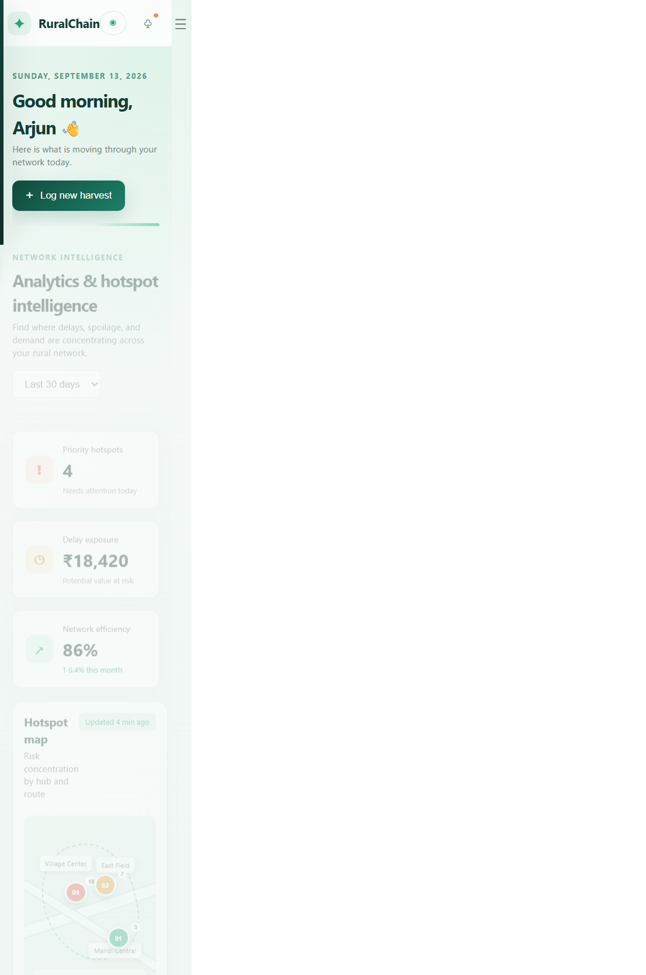
Figure 4.6: Implemented analytics screen for hotspot, delay, capacity, and temperature risk analysis.
Parcel tracking and custody timeline screen implemented in the RuralChain MVP:

Figure 4.7: Implemented parcel tracking screen with search, live status, custody events, ETA, and condition score.
Project repository: https://github.com/vesperhalcro-oss/Smart-Supply-Chain-Management-For-Rural-Area

